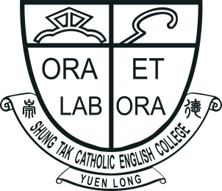 |  | SHUNG TAK CATHOLIC ENGLISH COLLEGE  ‘All Write Now!’  English Writing Competition 2023  Application Form  (Please use a separate form for each entry.) |  | 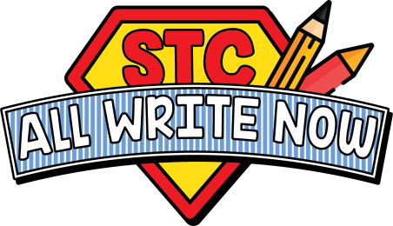
Name of Student: |  |  | Current Level: |  | Primary ☐ 5 / ☐ 6
Contact Number: |  |  | Email:
Name of School:
Responsible Teacher:
Contact Number: |  |  | Email:
Chosen Topic: | ☐ 1. On your school’s Open Day, you accidentally discovered a time capsule that was buried 65 years ago. Write a story about what you found inside the time capsule and what stories they would tell about the school’s past.  ☐ 2. Imagine you embodied with the superpower to travel back in time to visit your school’s very first day when it opened 65 years ago. Write a journal entry to describe the experience.
(Please enter your work in the text box below. Start a new page as needed.)
All entries should be submitted via email to allwritenow@stc.edu.hk
Submission Deadline: Tuesday 31st October, 2023

