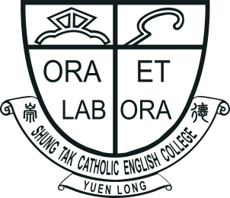 |  | SHUNG TAK CATHOLIC ENGLISH COLLEGE  ‘All Write Now!’  English Writing Competition 2022  Application Form  (Please use a separate form for each entry.) |  | 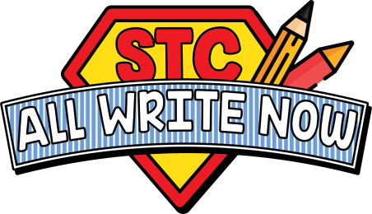
Name of Student: |  |  | Current Level: |  | Primary ☐ 5 / ☐ 6
Contact Number: |  |  | Email:
Name of School:
Responsible Teacher:
Contact Number: |  |  | Email:
Chosen Topic: | ☐ 1. Rewrite ‘The Three Little Pigs’ from the perspective of the wolf.  ☐ 2. Is social media actually connecting people?
(Please enter your work in the text box below.)
All entries should be submitted via email to allwritenow@stc.edu.hk
Submission Deadline: Monday 31st October, 2022

