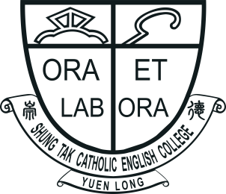 |  | SHUNG TAK CATHOLIC ENGLISH COLLEGE  ‘All Write Now!’  English Writing Competition 2021  Application Form  (Please use a separate form for each entry.) |  | 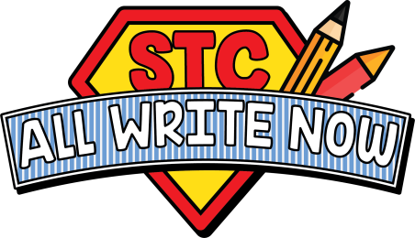
Name of Student: |  |  | Current Level: |  | Primary ☐ 5 / ☐ 6
Contact Number: |  |  | Email:
Name of School:
Responsible Teacher:
Contact Number: |  |  | Email:
Chosen Topic: | ☐ 1. ‘You pick up the phone and you hear the voice of someone you met  many years ago…’  ☐ 2. ‘Has the Tokyo 2020 Olympic/Paralympic Games brought about  change in Hong Kong society? If so, how?’
(Please enter your work in the text box below.)
All entries should be submitted via email to allwritenow@stc.edu.hk
Submission Deadline: Friday 29th October, 2021

